Glaucoma is defined as damage to retinal ganglion cell (RGC) axon within the laminar cribrosa (LC) region [1]. There are mainly two types of hypotheses injury the RGC axon: 1) direct insult by stress/strain on the axon (compression, tension, shear) when LC is being deformed or “growth” into a new configuration; 2) insult arise from IOP-related blood flow reduction and disruption of axoplasmic transport [1][4].

Although lowing IOP is the only proven method of slowing the progression of glaucoma. The tricky part is, there is patient who develop glaucoma at normal level of IOP (normal tension glaucoma) and patient who has elevated IOP but does not develop glaucoma (ocular hypertension). This indicates that IOP is not the only factor for glaucoma development. Trans-lamina pressure (TLP) is hypothesized to be the key contributing factor [2]. TLP is the pressure gradient across the LC, with IOP in the anterior end and cerebrospinal fluid pressure in the posterior end. In normal tension glaucoma, patients may have low cerebrospinal fluid pressure, so even though the IOP level is normal, the TLP is large enough to develop glaucoma. For ocular hypertension patients, they may have high cerebrospinal fluid pressure, which lowers the TLP and will not develop glaucoma. A computational study [3] also revealed that the microstructure of LC is a very dominant factor when assessing the stress/strain. A model with details microstructure of lamina beam shows that stress/strain is several times higher than a homogeneous model (essentially treat the LC structure as a block of element). So the specific geometry of each patient’s LC might lead to different level of stress concentration and prone to glaucoma injury.

Peripapillary sclera (PPS) mechanical property has a great influence on the ONH biomechanic. A monkey model has shown that acute IOP elevation caused the scleral canal to expand, which will tighten the lamina beams and make the LC more resistant to posterior deformation [1].
A pig eye model experimental study [6] reported that sclera stiffening can reduce the ONH tangential strain and it could be protective but increase in ONH shear strain and ONH posterior displacement could be detrimental. In sclera stiffening group, PPS radial and tangential strains reduced by 30.9% and 18.1% shear strain did not change. ONH tangential strains decreased by 15% but shear strain increased by 11.8% and radial strain did not change. After exposing to IOP elevation, the posterior displacement of ONH relative to PPS was 151.4 +- 33.9 micrometer before sclera stiffening. This displacement increased to 194.8 +- 41.3 micrometer after sclera stiffening.

The dominant stress within the LC is in-wall hoop stress, which is 15 times greater than the TPL [1]. Hence, consideration of in-wall hoop stress is very important when building models for LC deformation.

Axoplasmic transport disruption or axonal damage may first occur at the location where the translaminar tissue pressure gradient is greatest [1].

ONH cross section:
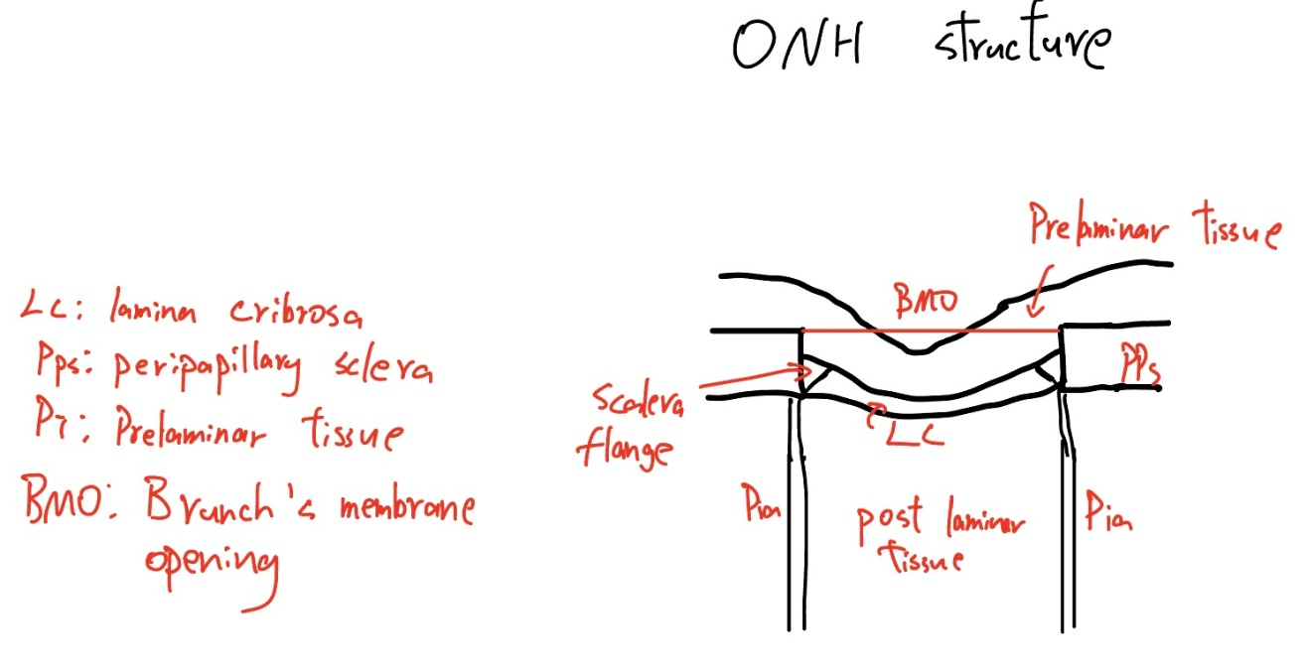

Prelaminar neural tissue:
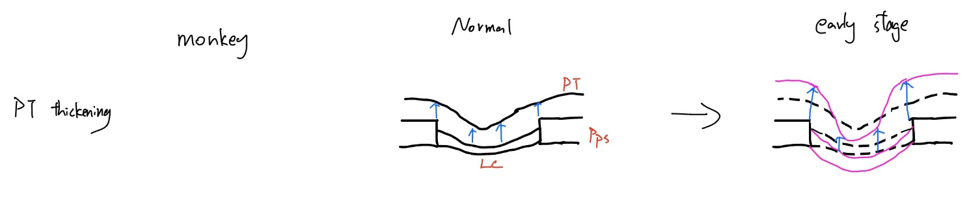Schematic of PT thickening

From monkey model, prelaminar neural tissues are significantly thickened at the earliest detectable stage of glaucoma [1].
Experimental glaucoma monkey model study [8] tried to decouple the phenomenon of cupping into “prelaminar thinning (due to physical compression or RGC axon atrophy)” and “laminar deformation”. However, they actually find substantial increases in prelaminar tissue thickness (ranged from 47-82 micrometer, normal monkey is 5 micrometer) and mild increases in prelaminar tissue volume (ranged from 0.122-0.308${ mm}^{3}$; normal monkey is 0.031${ mm}^{3}$) in those early glaucoma monkey eyes. The thickening was most prominent in the peripheral regions of the neural canal. The loss of axon (they count the number) in early glaucoma optic nerve ranged from 16% to 30% compared to the contralateral normal optic nerve. Based on these results, they concluded that the cupping detected in early glaucoma is the result of deformation of connective tissue of neural canal wall and laminar cribrosa, rather than thinning of prelaminar tissue (they have shown that prelaminar is actually thicken). They hypothesize that this thickening is due to swelling of the prelaminar neural tissues.

Study [9] performs a short time period (around 2 minutes) IOP elevation (approximately 10mmHg) increased on glaucoma patients and healthy control (further divided into age-match group and young group). They found that laminar displacement is nearly zero and can be considered rigid when compared to prelaminar tissue displacement. Average prelaminar tissue thickness of glaucoma patients is 176 micrometers, while age-matched healthy group is 273 micrometers. The elevated IOP induces an average prelaminar tissue displacement (PTD) of 6.8 micrometers in glaucoma group, while PTD of healthy group is 20.8 micrometers. The percentage of PTD in healthy group is 2-fold higher than that in glaucoma group. This might be explained by increased prelaminar tissue stiffness resulting from tissue remodeling.

This experimental study [10] compares the prelaminar tissue between primary open angle glaucoma and normal tension glaucoma. They found that prelaminar tissue thickness in POAG is significantly thinner than NTG. This difference is greater in patients with early glaucoma. Study [11] reported a thickening in prelaminar tissue after lowering the IOP by surgery in patients with POAG. It may be explained that prelaminar thickness is influenced by IOP. When IOP is high (in POAG case) the prelaminar tissue is compressed more.
The mean prelaminar thickness in POAG group is 81.08 micrometers compared to NTG group 98.35 micrometers over all stage. In early glaucoma, PT thickness in POAG is 89.19 micrometers compared to NTG 111.13 micrometers.
NTG group is subdivided into 2 groups according to PT thickness. For PT thickness less than 100 micrometer, IOP is 14.7 mmHg; while thickness >100 micrometers, IOP is 12.97 micrometers.
The prelaminar tissue is more compliant in early stage of glaucoma, and the stiffness increases due to tissue remodeling as glaucoma progress. This might explain why the difference of thickness is more prominent in early stage of glaucoma.

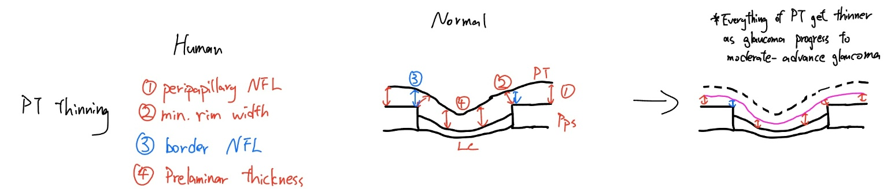Schematic of PT thinning

Study [19] compared “border NFL, peripapillary NFL, Minimum Rim Width (MRW), Minimum Rim Area (MRA), prelamina thickness, prelamina volume” between healthy control group, preperimetric glaucoma, early glaucoma and advanced glaucoma. Except MRA and prelamina volume did not significantly differ between control and preperimetric glaucoma group, every other measurement gets thinner or smaller as glaucoma progresses.
The results from this study suggest that there is structural damage to RNFL before clinically detectable loss of vision.

Study [23] performed optic nerve transection (ONT) with monkey eye and use OCT scan to monitor the prelamina tissue of both healthy and ONT eye. The whole duration is around 7 weeks, they found significant changes in the ONT eye for Minimum rim width(-26.2%), Retinal nerve fiber layer thickness (-43.8%), Prelamina tissue thickness (-23.8%), anterior lamina cribrosa surface depth (-20.8%). And no ONT eye demonstrated posterior deformation of lamina cribrosa.

(missing literature on prelaminar tissue atrophy)
LC thickening and posterior deformation:
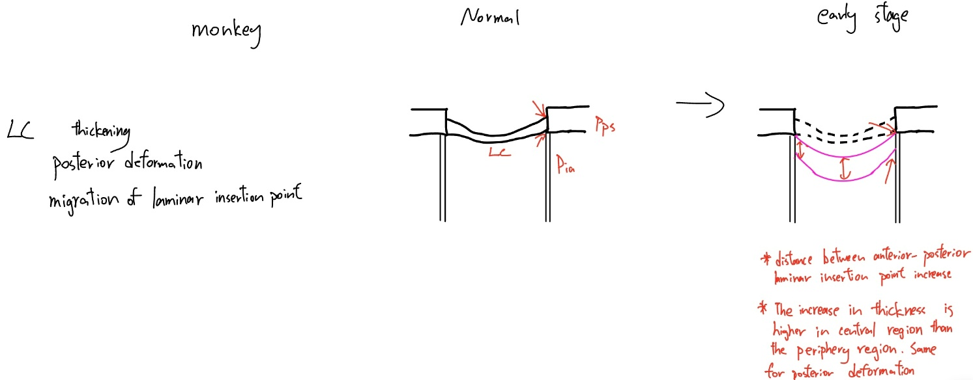Schematic of Laminar cribrosa thickening, posterior deformation and migration of laminar insertion point

With standard 2D histology, permanent posterior deformation and thickening of the LC occurs right after induction of chronic elevated IOP [4]

This study [4] reconstructed the 3D structure of the monkey LC, those three experiment early glaucoma monkeys’ eye (one eye induce glaucoma with laser, keeping the other eye normal) were significantly thicken (average of 37 micrometer, 36% thicker) and posterior deformed (average of 98 micrometer, 93% deeper).
The mean number of laminar beams through thickness of the LC was greater in glaucoma eyes.

Study [5] reported significant posterior deformation of lamina in early glaucoma monkey eye (range from -79 to -118 micrometer), with the central, inferior and inferonasal subregion having the largest posterior deformation. The overall thickness of lamina was significantly increased (range from 23-61 micrometer).

Could look at the reference from rafael 2012 paper for more experimental data from monkey

Scleral flange and peripapillary sclera:
Study [5] reported that thickness of scleral flange and peripapillary sclera doesn’t have significant differences. Scleral flange and pps immediately surrounding the ONH were also posteriorly displaced relative to the more peripheral sclera.

LC connective tissue volume fraction (CTVF) and beams orientation
CTVF is markedly higher in the central region, particularly in areas encompassing the central vascular trunk. All eyes exhibit region of low CTVF near the periphery of the LC [4].

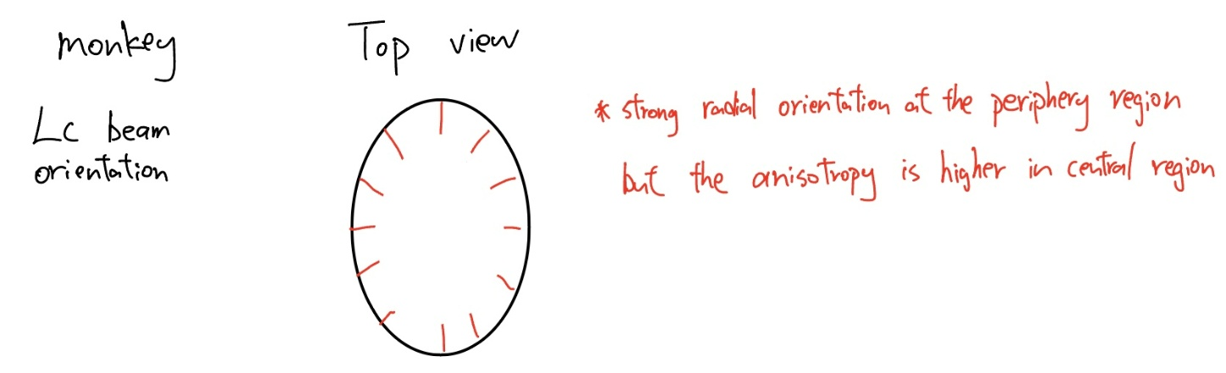
Schematic of laminar beam orientation

Lamina beam of periphery region shows a strong radial orientation. The primary orientation of lamina beams is within the plane of LC (not in anterior-posterior direction) direction. The lamina beams are less oriented in the periphery of LC and more oriented in the central region[4].

Glaucoma and normal eye show no significant differences in these two aspects [4] (CTVF and orientation)

Lamina cribrosa insertion point
Study [20] reported an outward migration of both anterior and posterior laminar insertion point (ALI & PLI). The outward migration of PLI ranged from 22 to 44 micrometer. The distance between ALI and PLI increased by 32 micrometers, which is essentially thickening. The study hypothesis that the outward migration of ALI maybe the result of physical trauma or remodeling in anterior lamina beam. While the migration of posterior end may be the result of remodeling that include retrolaminar recruitment.

Laminar pores:
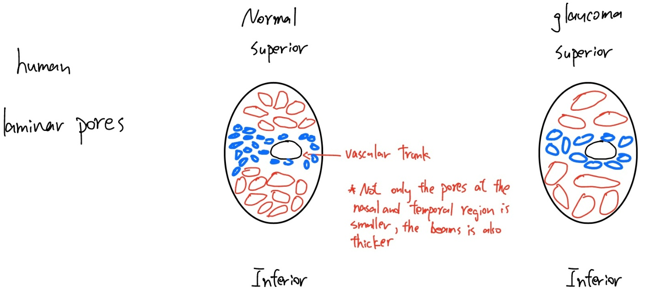
Schematic of laminar pores

A study [16] analyzed the pore shape and size of the LC and reported that as glaucoma progressed, the shape of lamina pores becomes oval and tend to enlarge and fused (They count the size by pixel. Control group: 724 pixel & Glaucoma group: 1561 pixel) . The number of pores also increased (Control group: 11.9 & Glaucoma group: 24.9).

Quigley [18] examined healthy human lamina pores and reported that the superior and inferior part of the lamina at the level of scleral appear to contain larger pores and thinner and more rope-like connective tissue than the nasal and temporal part. Therefore, it would be expected that the superior and inferior poles could be damaged more easily. The superior and inferior poles of lamina have pore size ranged to up 100 micrometers, while nasal and temporal parts of lamina rarely has pore size greater than 50 micrometers. The pores are smaller and connective tissue is thicker in the central part of the nerve head compared with the periphery.

Changes in elastin appearance:
Quigley et.al. [12] has shown degree of nerve fibre loss (glaucomatous damage) is correlated with the appearance of elastin in the LC. As elastin in glaucoma eye appears in curled shape rather than straight in healthy eye. The authors observed that the number of elastin fibers in glaucomatous eyes seemed qualitatively normal [12]. Furthermore, their subsequent study [13] using electron microscopy showed no difference in the number or diameter of elastin fibers between glaucomatous eye and normal eye. The authors explain this observation is due to the fact that elastin is a hardy molecule, the intrinsic property is difficult to be altered.
As glaucoma progresses, elastin appears to be separated from other components in disorganised laminar beams [12]. This phenomenon has also been observed in other studies [14][15]. The authors reported that elastin is synthesized after glaucomatous injury (an increase in elastin expression), but in a granular structure instead of fiber or tubular form [14]. Therefore, the newly synthesized elastin cannot attach to other ECM components. Eventually, elastin fibers lose their elasticity and not able to assist ONH in restoring its original geometry.

ONH cup and disc:
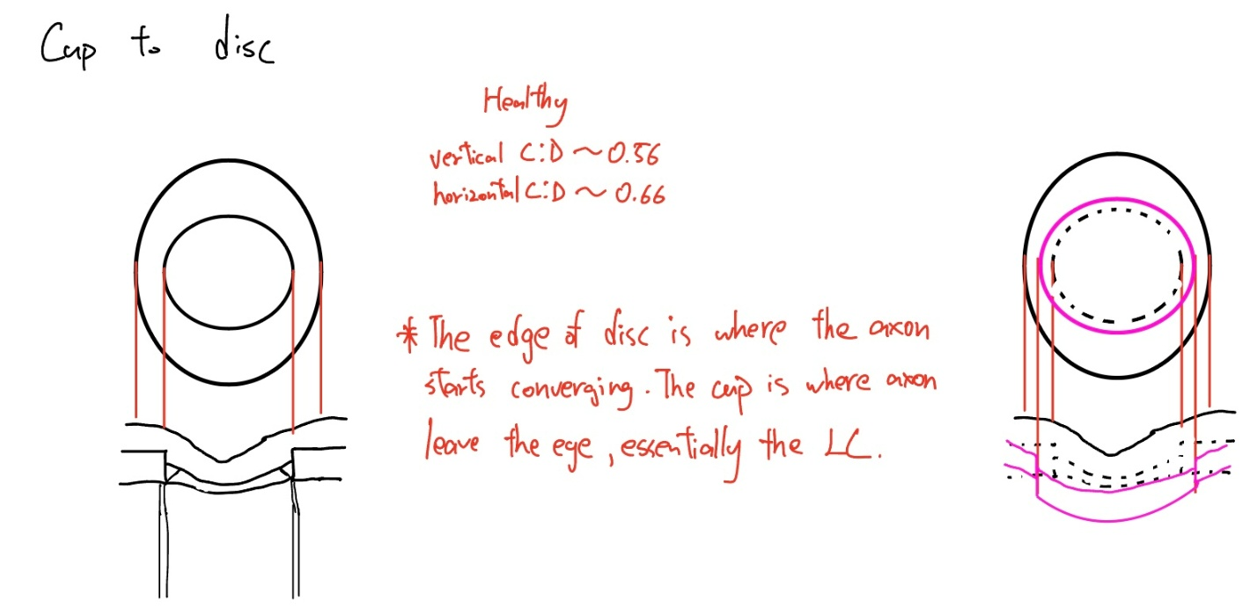
Schematic of cup to disc

This cup to disk structure is essentially viewing a cup (like an inverted trapezium) from the top. The edge is where retinal ganglion cell axon starts converging, the distance between edge of disk and the cup is the rim, this area is filled with axon and neural tissue. The cup is the exit, it is lamina cribrosa.

A normal optic disk is vertically oval, and the cup is horizontally oval. A larger disk will have a larger cup, small disk will usually have no cup [7]. The mean horizontal C:D diameter ratio is 0.66 and the mean vertical C:D diameter ratio is 0.56. As glaucoma progresses, the cup area increases (due to expanding and posterior deformation), the C:D ratio increases and hence, the neuroretina rim area (NRR) decreases. Less NRR means a more severe neural tissue atrophy. That’s why C:D ratio is an important parameter when assessing the severity of glaucoma.

References:
[1]The mechanical environment of the optic nerve head in glaucoma
[2] The role of lamina cribrosa tissue stiffness and fibrosis as fundamental biomechanical drivers of pathological glaucomatous cupping
[3] modeling the biomechanics of the lamina cribrosa microstructure in the human eye
[4] remodeling of the connective tissue microarchitecture of the lamina cribrosa in early experimental glaucoma
[5] 3-D histomorphometry of the normal and early glaucomatous monkey optic nerve head: lamina cribrosa and peripapillary scleral position and thickness
[6] Peripapillary scleral stiffening increases optic nerve head shear deformation in porcine eyes during IOP elevation
[7] evaluation of the optic nerve head in glaucoma
[8] 3-D histomorphometry of the normal and early glaucomatous monkey optic nerve head: prelaminar neural tissues and cupping
[9] laminar and prelaminar tissue displacement during intraocular pressure elevation in glaucoma patients and healthy controls
[10] comparison of prelaminar thickness between primary open angle glaucoma and normal tension glaucoma patients
[11] laminar displacement and prelaminar tissue thickness change after glaucoma surgery imaged with optical coherence tomography.
[12] alterations in elastin of the optic nerve head in human and experimental glaucoma
[13] Quantitative studies of elastin in the optic nerve heads of persons with primary open-angle glaucoma.
[14] Ultrastructural immunocytochemical analysis of elastin in the human laminar cribrosa
[15] Increased elastin expression in astrocytes of the lamina cribrosa in response to elevated intraocular pressure
[16] In vivo characterization of lamina cribrosa pore morphology in primary open-angle glaucoma
[17] Alterations in the morphology of lamina cribrosa pores in glaucomatous eyes
[18] Regional Differences in the Structure of the Lamina Cribrosa and Their Relation to Glaucomatous Optic Nerve Damage
[19] quantifying biomarkers of axonal degeneration in early glaucoma to find the disc at risk
[20] Optic Nerve Head (ONH) Lamina Cribrosa Insertion Migration and Pialization in Early Non-Human Primate (NHP) Experimental Glaucoma
[21] A Biomechanical Paradigm for Axonal Insult Within the Optic Nerve Head
[22] Chronic experimental glaucoma in primates II. Effect of extended intraocular pressure elevation on optic nerve head and axonal transport
[23] Cupping in the Monkey Optic Nerve Transection Model Consists of Prelaminar Tissue Thinning in the Absence of Posterior Laminar Deformation

